What are Design Patterns?
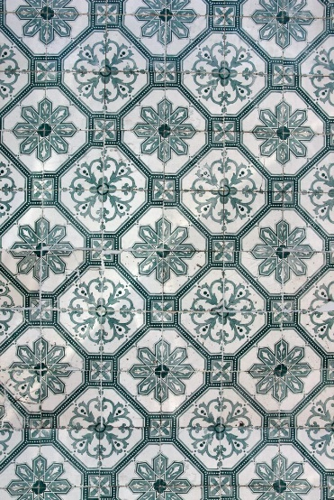
- Definition – Design patterns are well-established resolutions for repetitive challenges in software design. Design patterns function as frameworks that developers can use to address typical architectural difficulties. In addition, patterns guarantee dependability, adaptability and ease of code maintenance.
- Purpose – Design patterns aim to elevate software development practices by offering standardized solutions. Patterns are vital in organizing code, promoting reusability and simplifying the design process. By adhering to established patterns, developers can avoid unnecessary repetition and focus more on creating efficient, high-quality applications.
- Benefits – Implementing design patterns in software development yields numerous benefits. These include:
1. Code Reusability: Design patterns encourage the reuse of proven solutions, cut redundant code and save valuable development time. As a result, the use of design patterns improves production and efficiency in the software development process.
2. Scalability: Design patterns provide flexible structures. The structures can adjust to shifting needs and accommodate future expansions. This scalability ensures that software systems can grow without significant architectural overhaul.
3. Maintainability: By utilizing design patterns, code becomes more modular and easier to maintain. Developers can change specific software parts without impacting the entire application, which simplifies troubleshooting and updates.
4. Collaboration: Design patterns establish a widely-used language for developers, which also fosters effective communication and understanding of the software’s architecture. Communication enables seamless collaboration among team members, promoting synergy and collective problem-solving.

Types of Design Patterns
Creational patterns revolve around object-creation mechanisms and provide flexible ways to create objects, while promoting code encapsulation and decoupling.
- Singleton – A class can only have one instance, thanks to the Singleton design. It ensures a global access point as well. This pattern is proper when there should be a single class instance throughout the application.
- Factory – The Factory pattern abstracts the process of object creation and allows subclasses or derived classes to determine which class to instantiate. The Factory pattern also provides a central factory class that encapsulates object creation logic.
Structural patterns deal with the composition of classes and objects, defining how they can be combined to form larger structures or functionalities.
- Adapter – The Adapter pattern converts the interface of a class into another interface that clients expect, enabling types with incompatible interfaces to work together as a bridge.
- Decorator – The Decorator pattern dynamically adds new behaviors to an object by wrapping it in a decorator class. It offers a flexible alternative to subclassing for extending the functionality of an object.
- Behavioral Patterns – Behavioral patterns focus on communication and interaction between objects, plus define how objects collaborate to do complex tasks.
- Observer – The Observer pattern establishes a one-to-many dependency between objects. In this case, changes in one object trigger updates in other dependent things.
- Strategy – The Strategy pattern defines several interchangeable algorithms and encapsulates each separately. The pattern allows algorithms to be selected at runtime depending on their employed situation.

How to Use Design Patterns

Identifying the Problem
To effectively leverage design patterns, it is crucial to identify the problem or scenario that requires a solution. This approach entails understanding the software architecture‘s requirements, constraints and potential areas for enhancement.

Selecting the Appropriate Pattern
Once the issue has been identified, the following step is carefully selecting the most appropriate design pattern. Each pattern serves a distinct purpose within a specific context. That’s why it is important to consider scalability, maintainability and code complexity.

Implementing the Chosen Pattern
Once the design pattern has been chosen, developers can proceed with the implementation phase. This phase involves creating the necessary classes and interfaces and establishing the relationships the selected pattern specifies. Accompanying the implementation with proper documentation and code comments is crucial to ensuring clarity for future maintainers.

Real-World Examples
Design patterns are prevalent in various software applications. Let’s explore a few real-world examples highlighting the practical usage of design patterns:
- MVC (Model-View-Controller) Architecture: Developers widely employ this architectural pattern in web development frameworks. It separates the application into three components: the model (data and business logic), the view (user interface) and the controller (handles user input and orchestrates interactions between the model and view). MVC promotes code organization, modularity and ease of maintenance.
- Iterator Pattern: The iterator pattern is used in programming languages and frameworks that provide collections of objects. It offers a way to access elements of a group sequentially without exposing its internal representation. The iterator pattern simplifies the traversal of complex data structures, encapsulating iteration logic.
- Factory Pattern: Developers also widely deploy the factory pattern in software development to create objects without specifying their precise classes. The pattern provides an interface or base class for object creation. Subclasses or concrete implementations determine the specific performance. This pattern promotes loose coupling between client code and the objects it creates, facilitating flexibility and easier maintenance. A real-world example is a GUI toolkit. It utilizes the factory pattern to generate various graphical components based on user requirements or system configuration. For instance, buttons, text fields and checkboxes.
- Observer Pattern: The observer pattern provides a one-to-many dependency between objects, where the one (subject) notifies the many (observers) about any state changes. This pattern is commonly employed in event-driven systems or frameworks where many objects must respond to changes in other areas of the application. For instance, in a stock market application, various components like stock price displays, charts and notifications can act as observers that receive updates from a central stock market data source. The observer pattern enables loose coupling between the subject and observers, allowing dynamic and flexible interactions.

Conclusion
Design patterns are indispensable tools for software developers. They provide reusable solutions to recurring design challenges. By leveraging design patterns, developers can enhance code reusability, scalability and maintainability. Familiarity with various design patterns and their appropriate usage empowers developers to build efficient and robust software applications.
To use design patterns effectively, developers must first identify the problem or scenario that requires a solution. When the problem is identified, the most fitted design pattern can be selected. The implementation phase involves creating the necessary classes and interfaces and establishing the relationships specified by the chosen pattern.

Design Pattern - Overview

Design patterns represent the best practices used by experienced object-oriented software developers. Design patterns are solutions to general problems that software developers faced during software development. These solutions were obtained by trial and error by numerous software developers over quite a substantial period of time.

What is Gang of Four (GOF)?
In 1994, four authors Erich Gamma, Richard Helm, Ralph Johnson and John Vlissides published a book titled Design Patterns - Elements of Reusable Object-Oriented Software which initiated the concept of Design Pattern in Software development.
These authors are collectively known as Gang of Four (GOF). According to these authors design patterns are primarily based on the following principles of object orientated design.
- Program to an interface not an implementation
- Favor object composition over inheritance

Usage of Design Pattern
Design Patterns have two main usages in software development.

Common platform for developers
Design patterns provide a standard terminology and are specific to particular scenario. For example, a singleton design pattern signifies use of single object so all developers familiar with single design pattern will make use of single object and they can tell each other that program is following a singleton pattern.

Best Practices
Design patterns have been evolved over a long period of time and they provide best solutions to certain problems faced during software development. Learning these patterns helps unexperienced developers to learn software design in an easy and faster way.

Types of Design Patterns
As per the design pattern reference book Design Patterns - Elements of Reusable Object-Oriented Software , there are 23 design patterns which can be classified in three categories: Creational, Structural and Behavioral patterns. We'll also discuss another category of design pattern: J2EE design patterns.
S.N. | Pattern & Description
1 | Creational Patterns  These design patterns provide a way to create objects while hiding the creation logic, rather than instantiating objects directly using new operator. This gives program more flexibility in deciding which objects need to be created for a given use case.
2 | Structural Patterns  These design patterns concern class and object composition. Concept of inheritance is used to compose interfaces and define ways to compose objects to obtain new functionalities.
3 | Behavioral Patterns  These design patterns are specifically concerned with communication between objects.
4 | J2EE Patterns  These design patterns are specifically concerned with the presentation tier. These patterns are identified by Sun Java Center.

Design Pattern - Factory Pattern

Factory pattern is one of the most used design patterns in Java. This type of design pattern comes under creational pattern as this pattern provides one of the best ways to create an object.
In Factory pattern, we create object without exposing the creation logic to the client and refer to newly created object using a common interface.

Implementation
We're going to create a Shape interface and concrete classes implementing the Shape interface. A factory class ShapeFactory is defined as a next step.
FactoryPatternDemo, our demo class will use ShapeFactory to get a Shape object. It will pass information (CIRCLE / RECTANGLE / SQUARE) to ShapeFactory to get the type of object it needs.
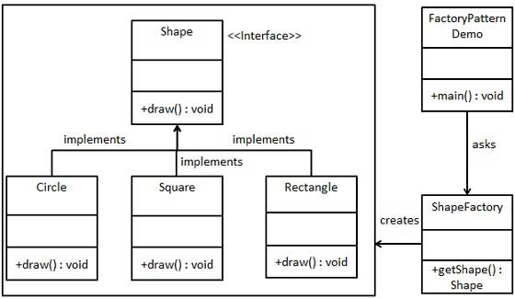

Step 1
Create an interface.
Shape.java
public interface Shape {
void draw();
}

Step 2
Create concrete classes implementing the same interface.
Rectangle.java
public class Rectangle implements Shape {

@Override
public void draw() {
System.out.println("Inside Rectangle::draw() method.");
}
}
Square.java
public class Square implements Shape {

@Override
public void draw() {
System.out.println("Inside Square::draw() method.");
}
}
Circle.java
public class Circle implements Shape {

@Override
public void draw() {
System.out.println("Inside Circle::draw() method.");
}
}

Step 3
Create a Factory to generate object of concrete class based on given information.
ShapeFactory.java
public class ShapeFactory {

//use getShape method to get object of type shape
public Shape getShape(String shapeType){
if(shapeType == null){
return null;
}
if(shapeType.equalsIgnoreCase("CIRCLE")){
return new Circle();

} else if(shapeType.equalsIgnoreCase("RECTANGLE")){
return new Rectangle();

} else if(shapeType.equalsIgnoreCase("SQUARE")){
return new Square();
}

return null;
}
}

Step 4
Use the Factory to get object of concrete class by passing an information such as type.
FactoryPatternDemo.java
public class FactoryPatternDemo {

public static void main(String[] args) {
ShapeFactory shapeFactory = new ShapeFactory();

//get an object of Circle and call its draw method.
Shape shape1 = shapeFactory.getShape("CIRCLE");

//call draw method of Circle
shape1.draw();

//get an object of Rectangle and call its draw method.
Shape shape2 = shapeFactory.getShape("RECTANGLE");

//call draw method of Rectangle
shape2.draw();

//get an object of Square and call its draw method.
Shape shape3 = shapeFactory.getShape("SQUARE");

//call draw method of square
shape3.draw();
}
}

Step 5
Verify the output.
Inside Circle::draw() method.
Inside Rectangle::draw() method.
Inside Square::draw() method.

Design Pattern - Abstract Factory Pattern

Abstract Factory patterns work around a super-factory which creates other factories. This factory is also called as factory of factories. This type of design pattern comes under creational pattern as this pattern provides one of the best ways to create an object.
In Abstract Factory pattern an interface is responsible for creating a factory of related objects without explicitly specifying their classes. Each generated factory can give the objects as per the Factory pattern.

Implementation
We are going to create a Shape interface and a concrete class implementing it. We create an abstract factory class AbstractFactory as next step. Factory class ShapeFactory is defined, which extends AbstractFactory. A factory creator/generator class FactoryProducer is created.
AbstractFactoryPatternDemo, our demo class uses FactoryProducer to get a AbstractFactory object. It will pass information (CIRCLE / RECTANGLE / SQUARE for Shape) to AbstractFactory to get the type of object it needs.
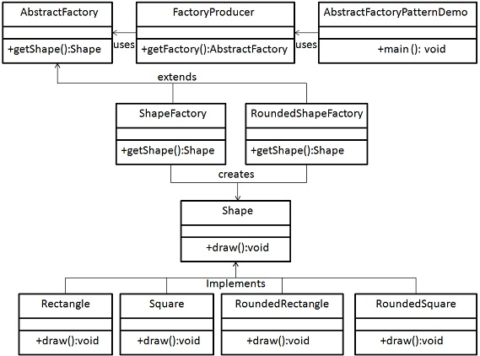

Step 1
Create an interface for Shapes.
Shape.java
public interface Shape {
void draw();
}

Step 2
Create concrete classes implementing the same interface.
RoundedRectangle.java
public class RoundedRectangle implements Shape {
@Override
public void draw() {
System.out.println("Inside RoundedRectangle::draw() method.");
}
}
RoundedSquare.java
public class RoundedSquare implements Shape {
@Override
public void draw() {
System.out.println("Inside RoundedSquare::draw() method.");
}
}
Rectangle.java
public class Rectangle implements Shape {
@Override
public void draw() {
System.out.println("Inside Rectangle::draw() method.");
}
}

Step 3
Create an Abstract class to get factories for Normal and Rounded Shape Objects.
AbstractFactory.java
public abstract class AbstractFactory {
abstract Shape getShape(String shapeType) ;
}

Step 4
Create Factory classes extending AbstractFactory to generate object of concrete class based on given information.
ShapeFactory.java
public class ShapeFactory extends AbstractFactory {
@Override
public Shape getShape(String shapeType){
if(shapeType.equalsIgnoreCase("RECTANGLE")){
return new Rectangle();
}else if(shapeType.equalsIgnoreCase("SQUARE")){
return new Square();
}
return null;
}
}
RoundedShapeFactory.java
public class RoundedShapeFactory extends AbstractFactory {
@Override
public Shape getShape(String shapeType){
if(shapeType.equalsIgnoreCase("RECTANGLE")){
return new RoundedRectangle();
}else if(shapeType.equalsIgnoreCase("SQUARE")){
return new RoundedSquare();
}
return null;
}
}

Step 5
Create a Factory generator/producer class to get factories by passing an information such as Shape
FactoryProducer.java
public class FactoryProducer {
public static AbstractFactory getFactory(boolean rounded){
if(rounded){
return new RoundedShapeFactory();
}else{
return new ShapeFactory();
}
}
}

Step 6
Use the FactoryProducer to get AbstractFactory in order to get factories of concrete classes by passing an information such as type.
AbstractFactoryPatternDemo.java
public class AbstractFactoryPatternDemo {
public static void main(String[] args) {
//get shape factory
AbstractFactory shapeFactory = FactoryProducer.getFactory(false);
//get an object of Shape Rectangle
Shape shape1 = shapeFactory.getShape("RECTANGLE");
//call draw method of Shape Rectangle
shape1.draw();
//get an object of Shape Square
Shape shape2 = shapeFactory.getShape("SQUARE");
//call draw method of Shape Square
shape2.draw();
//get shape factory
AbstractFactory shapeFactory1 = FactoryProducer.getFactory(true);
//get an object of Shape Rectangle
Shape shape3 = shapeFactory1.getShape("RECTANGLE");
//call draw method of Shape Rectangle
shape3.draw();
//get an object of Shape Square
Shape shape4 = shapeFactory1.getShape("SQUARE");
//call draw method of Shape Square
shape4.draw();

}
}

Step 7
Verify the output.
Inside Rectangle::draw() method.
Inside Square::draw() method.
Inside RoundedRectangle::draw() method.
Inside RoundedSquare::draw() method.

Design Pattern - Singleton Pattern

Singleton pattern is one of the simplest design patterns in Java. This type of design pattern comes under creational pattern as this pattern provides one of the best ways to create an object.
This pattern involves a single class which is responsible to create an object while making sure that only single object gets created. This class provides a way to access its only object which can be accessed directly without need to instantiate the object of the class.

Implementation
We're going to create a SingleObject class. SingleObject class have its constructor as private and have a static instance of itself.
SingleObject class provides a static method to get its static instance to outside world. SingletonPatternDemo, our demo class will use SingleObject class to get a SingleObject object.
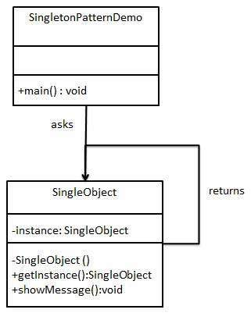

Step 1
Create a Singleton Class.
SingleObject.java
public class SingleObject {

//create an object of SingleObject
private static SingleObject instance = new SingleObject();

//make the constructor private so that this class cannot be
//instantiated
private SingleObject(){}

//Get the only object available
public static SingleObject getInstance(){
return instance;
}

public void showMessage(){
System.out.println("Hello World!");
}
}

Step 2
Get the only object from the singleton class.
SingletonPatternDemo.java
public class SingletonPatternDemo {
public static void main(String[] args) {

//illegal construct
//Compile Time Error: The constructor SingleObject() is not visible
//SingleObject object = new SingleObject();

//Get the only object available
SingleObject object = SingleObject.getInstance();

//show the message
object.showMessage();
}
}

Step 3
Verify the output.
Hello World!

Design Patterns - Builder Pattern

Builder pattern builds a complex object using simple objects and using a step by step approach. This type of design pattern comes under creational pattern as this pattern provides one of the best ways to create an object.
A Builder class builds the final object step by step. This builder is independent of other objects.

Implementation
We have considered a business case of fast-food restaurant where a typical meal could be a burger and a cold drink. Burger could be either a Veg Burger or Chicken Burger and will be packed by a wrapper. Cold drink could be either a coke or pepsi and will be packed in a bottle.
We are going to create an Item interface representing food items such as burgers and cold drinks and concrete classes implementing the Item interface and a Packing interface representing packaging of food items and concrete classes implementing the Packing interface as burger would be packed in wrapper and cold drink would be packed as bottle.
We then create a Meal class having ArrayList of Item and a MealBuilder to build different types of Meal objects by combining Item. BuilderPatternDemo, our demo class will use MealBuilder to build a Meal.
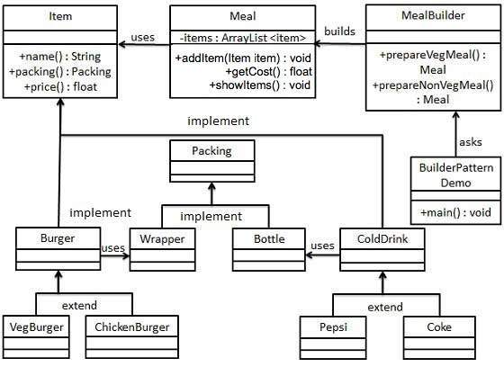

Step 1
Create an interface Item representing food item and packing.
Item.java
public interface Item {
public String name();
public Packing packing();
public float price();
}
Packing.java
public interface Packing {
public String pack();
}

Step 2
Create concrete classes implementing the Packing interface.
Wrapper.java
public class Wrapper implements Packing {

@Override
public String pack() {
return "Wrapper";
}
}
Bottle.java
public class Bottle implements Packing {

@Override
public String pack() {
return "Bottle";
}
}

Step 3
Create abstract classes implementing the item interface providing default functionalities.
Burger.java
public abstract class Burger implements Item {

@Override
public Packing packing() {
return new Wrapper();
}

@Override
public abstract float price();
}
ColdDrink.java
public abstract class ColdDrink implements Item {

@Override
public Packing packing() {
return new Bottle();
}

@Override
public abstract float price();
}

Step 4
Create concrete classes extending Burger and ColdDrink classes
VegBurger.java
public class VegBurger extends Burger {

@Override
public float price() {
return 25.0f;
}

@Override
public String name() {
return "Veg Burger";
}
}
ChickenBurger.java
public class ChickenBurger extends Burger {

@Override
public float price() {
return 50.5f;
}

@Override
public String name() {
return "Chicken Burger";
}
}
Coke.java
public class Coke extends ColdDrink {

@Override
public float price() {
return 30.0f;
}

@Override
public String name() {
return "Coke";
}
}
Pepsi.java
public class Pepsi extends ColdDrink {

@Override
public float price() {
return 35.0f;
}

@Override
public String name() {
return "Pepsi";
}
}

Step 5
Create a Meal class having Item objects defined above.
Meal.java
import java.util.ArrayList;
import java.util.List;

public class Meal {
private List<Item> items = new ArrayList<Item>();

public void addItem(Item item){
items.add(item);
}

public float getCost(){
float cost = 0.0f;

for (Item item : items) {
cost += item.price();
}
return cost;
}

public void showItems(){

for (Item item : items) {
System.out.print("Item : " + item.name());
System.out.print(", Packing : " + item.packing().pack());
System.out.println(", Price : " + item.price());
}
}
}

Step 6
Create a MealBuilder class, the actual builder class responsible to create Meal objects.
MealBuilder.java
public class MealBuilder {

public Meal prepareVegMeal (){
Meal meal = new Meal();
meal.addItem(new VegBurger());
meal.addItem(new Coke());
return meal;
}

public Meal prepareNonVegMeal (){
Meal meal = new Meal();
meal.addItem(new ChickenBurger());
meal.addItem(new Pepsi());
return meal;
}
}

Step 7
BuiderPatternDemo uses MealBuider to demonstrate builder pattern.
BuilderPatternDemo.java
public class BuilderPatternDemo {
public static void main(String[] args) {

MealBuilder mealBuilder = new MealBuilder();

Meal vegMeal = mealBuilder.prepareVegMeal();
System.out.println("Veg Meal");
vegMeal.showItems();
System.out.println("Total Cost: " + vegMeal.getCost());

Meal nonVegMeal = mealBuilder.prepareNonVegMeal();
System.out.println("\n\nNon-Veg Meal");
nonVegMeal.showItems();
System.out.println("Total Cost: " + nonVegMeal.getCost());
}
}

Step 8
Verify the output.
Veg Meal
Item : Veg Burger, Packing : Wrapper, Price : 25.0
Item : Coke, Packing : Bottle, Price : 30.0
Total Cost: 55.0

Non-Veg Meal
Item : Chicken Burger, Packing : Wrapper, Price : 50.5
Item : Pepsi, Packing : Bottle, Price : 35.0
Total Cost: 85.5

